How to convert a MARC file to Excel (or csv) format using MarcEdit | 
Yoel Kortick
Senior Librarian

Question:
I need to get bibliographic records from Alma into Excel format and be able to choose exactly which fields and subfields I need in the Excel. How can I do this?

Answer:
Please follow steps below.
In addition to the explanation below you may also to see the video https://www.youtube.com/watch?v=qkzJmNOvY00 from MarcEdit

ONE
Create a MARC file in Alma, for example by using the General Publishing Profile or the Export Bibliographic Records job. We will run the “Export Bibliographic Records” job.

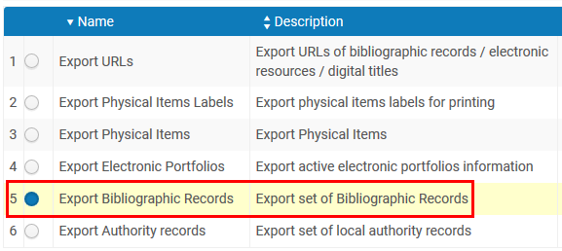

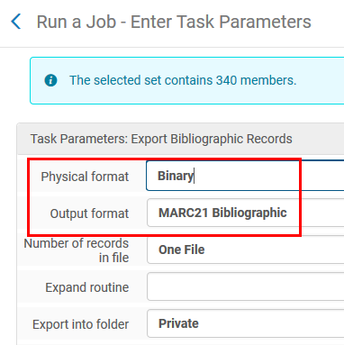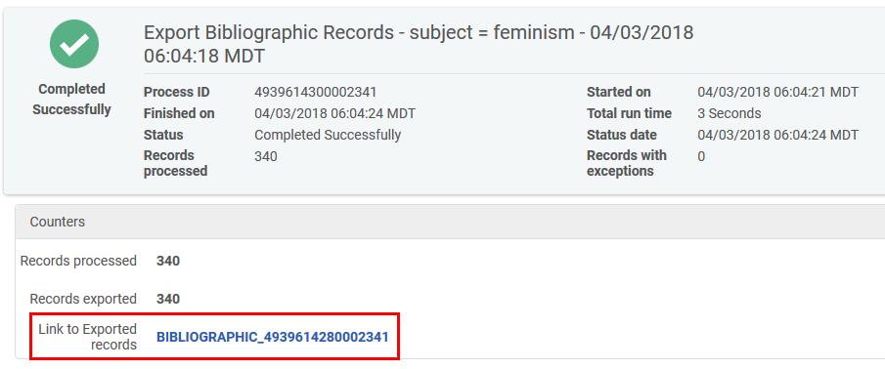

TWO
Identify location of MARC file

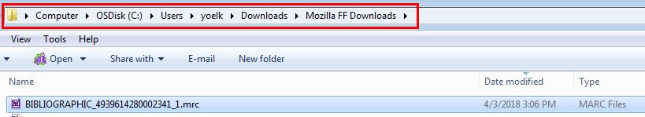

THREE
In MarcEdit do
- Tools > Export > Export Tab Delimited Records.
- Select Filed delimiter “Comma” (or of desired in different scenario choose “tab” or “pipe”). For repeatable fields note the “n field delimiter” semicolon
- Click “Next”
- Select fields and subfields to add
- Note that the settings can be saved or loaded from a previous save
- Click “Export”
- Receive message that the file has been exported

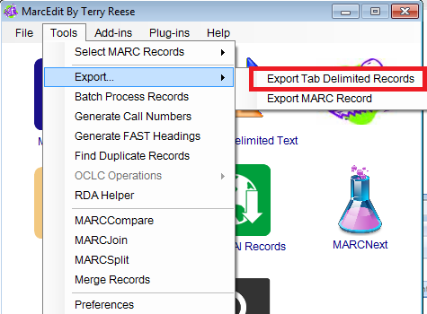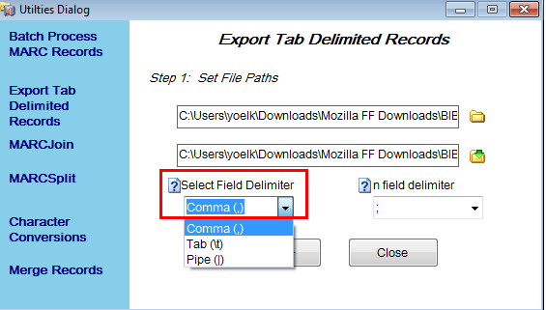

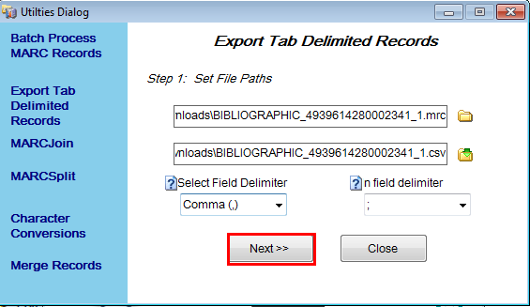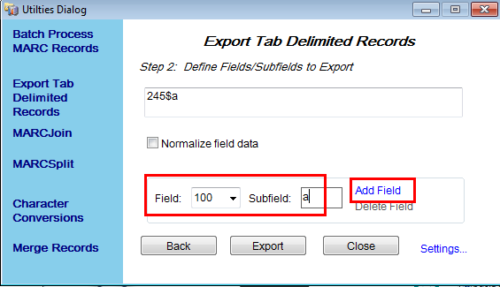

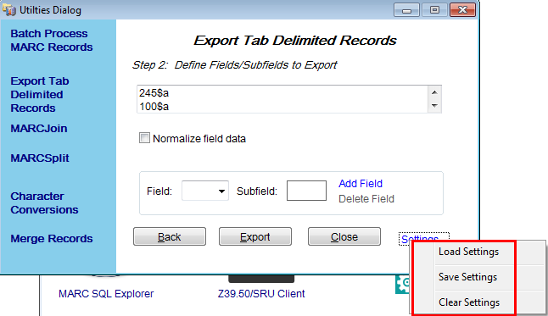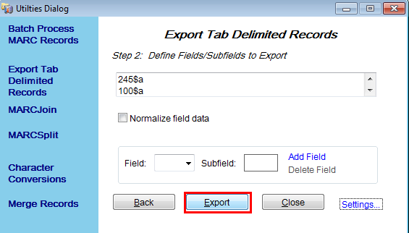

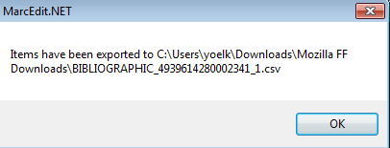

FOUR
Take a look at the file in Notepad or Notepad ++

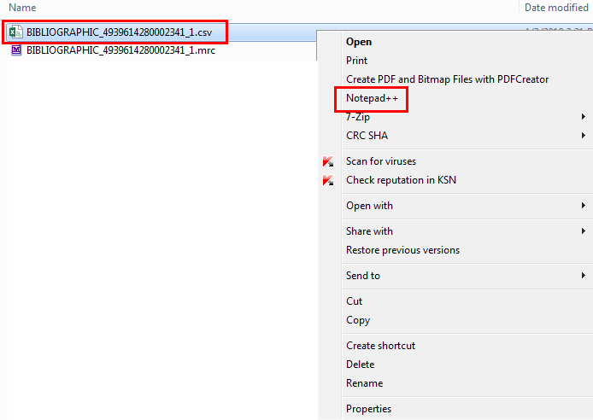

File looks great

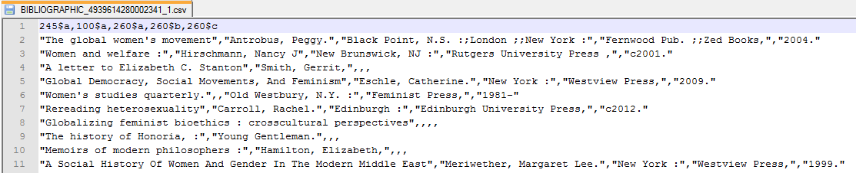

FIVE
Take a look at the file in Excel

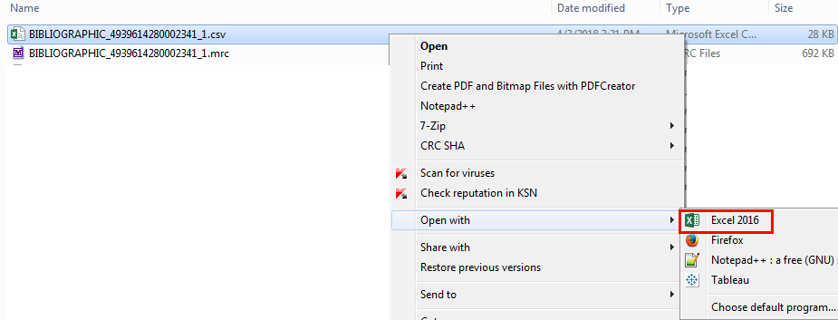

File looks great

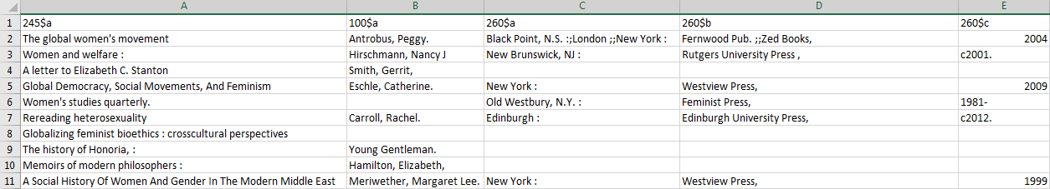

SIX

For repeatable fields note that happened becaseu we used “n field delimiter” semicolon.
Here we have three 260 $a and two 260 $b

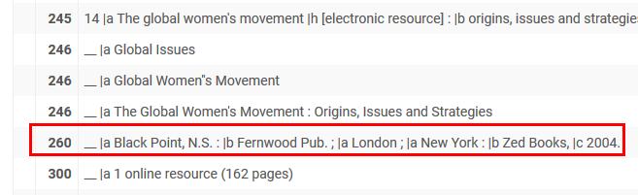

Each is semicolon separated within the comma-separated field.

